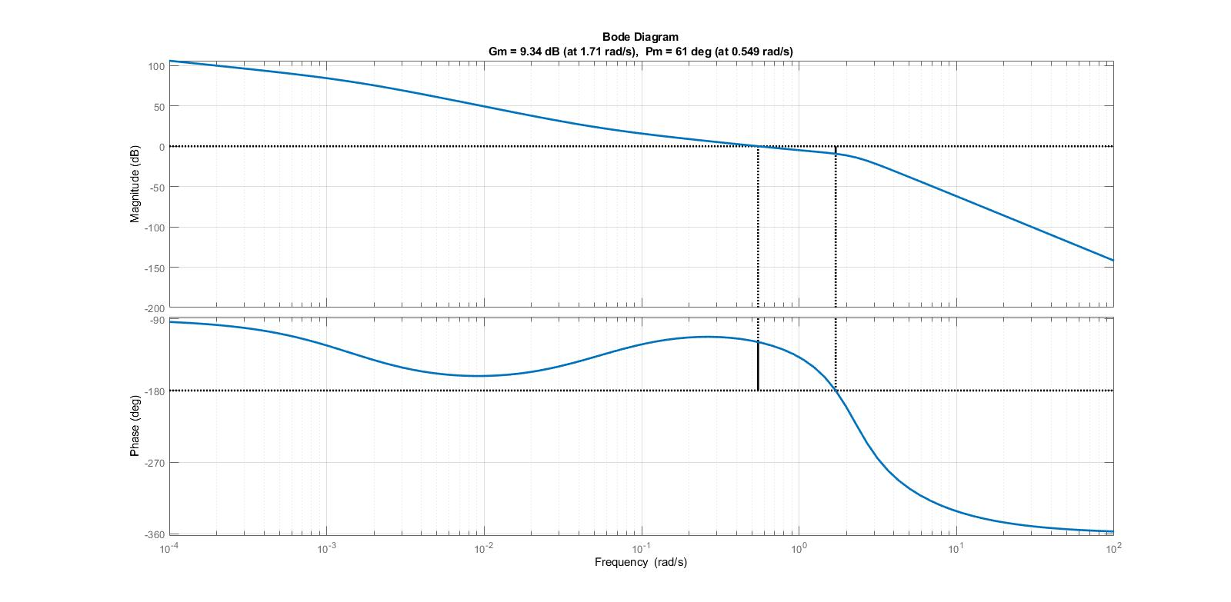(Q1

کد متلب سوال 1 :

clc;

clear all;

close all;

s=tf('s');

num =300\*(18.32\*s+1);

%num1 =5\*(s+1);

den=(683.89\*s+1)\*(s)\*(s+3)\*(s^2+2\*s+5);

sys=num/den;

%sys1=num1/den;

display(sys);

%display(sys1);

figure

bode(sys);

set(findall(figure(1),'type','line','linewidth',2))

title('bode with exponentioal');

margin(sys), grid

set(findall(figure(1),'type','line'),'linewidth',2)

grid on

(Q3

* 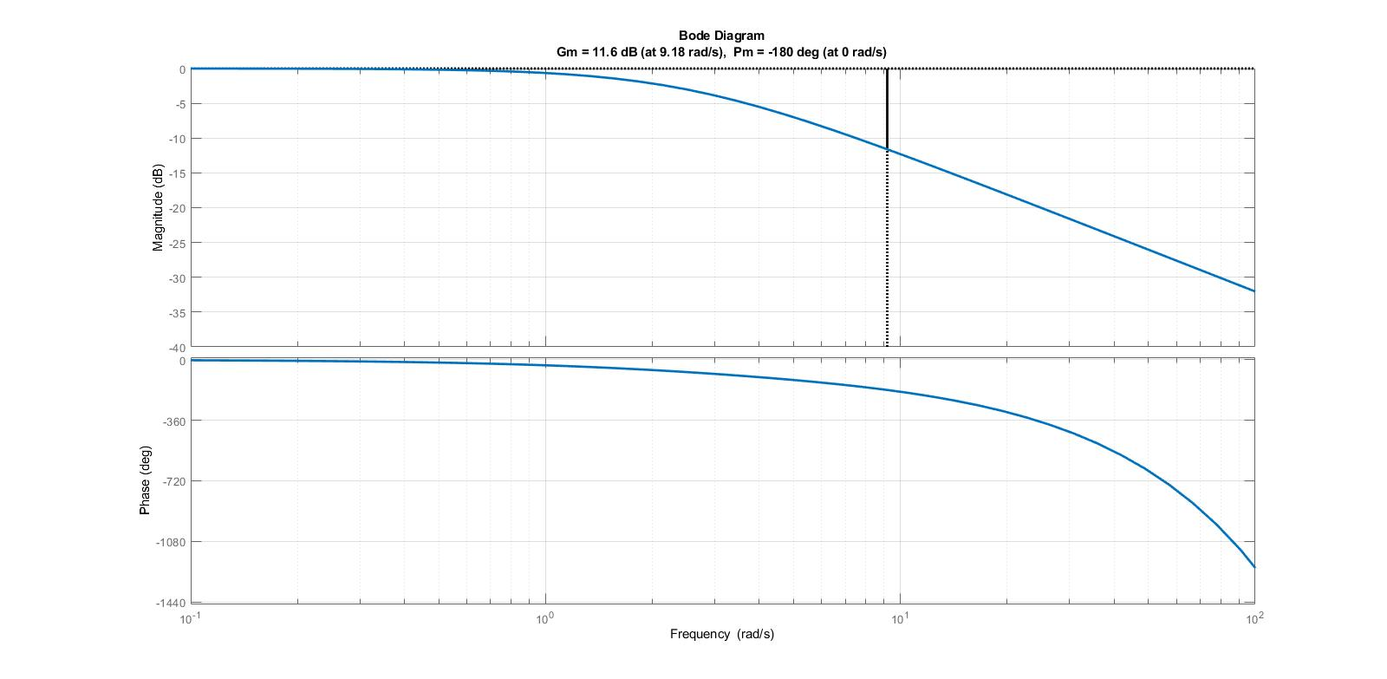پاسخ سیستم اصلی :
* 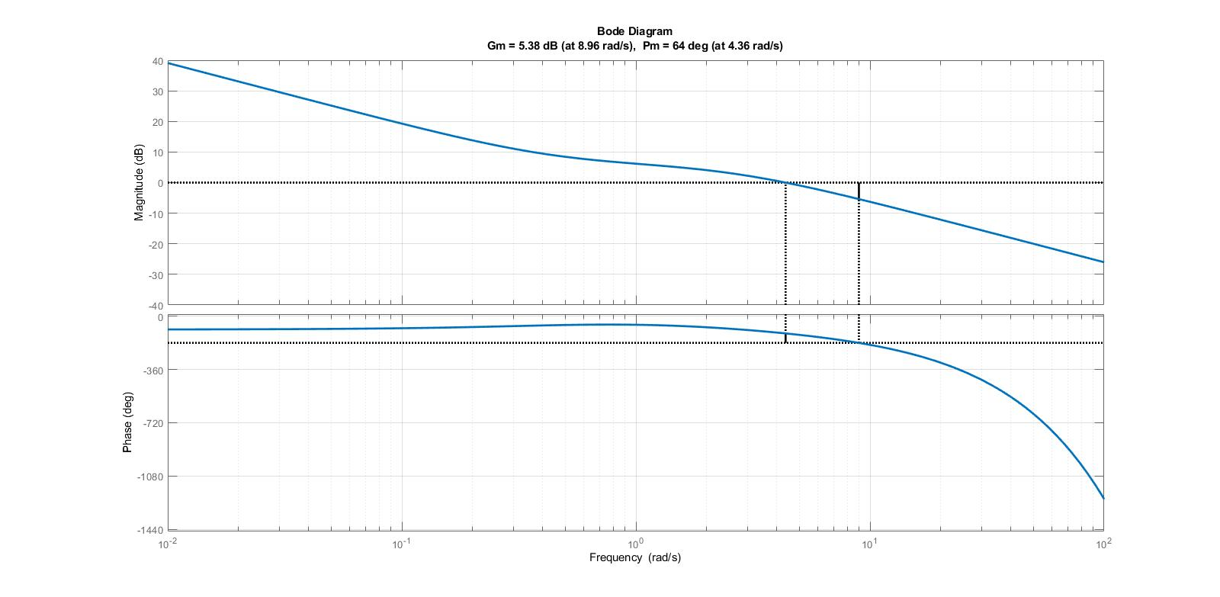پاسخ سیستم کنترل شده :

کد متلب سوال 3 :

clc;

clear all;

close all;

s=tf('s');

Cs=(2+0.9/s);

num =exp(-0.2\*s);

num1 =Cs\*num;

den=0.4\*s+1;

sys=num/den;

sys1=num1/den;

%display(sys);

display(sys1);

figure

bode(sys1);

set(findall(figure(1),'type','line','linewidth',2))

title('bode with exponentioal');

margin(sys1), grid

set(findall(figure(1),'type','line'),'linewidth',2)

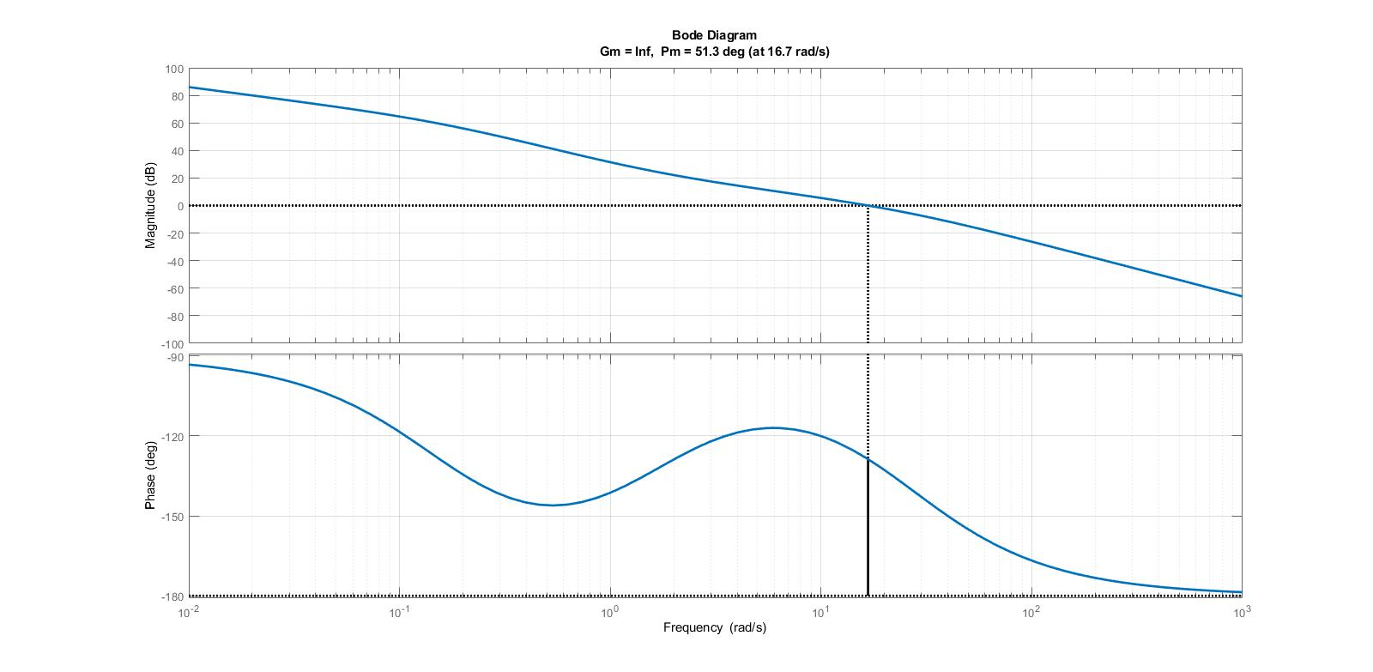(Q4

کد متلب سوال 4 :

clc;

clear all;

close all;

s=tf('s');

num =5000\*(0.62\*s+1);

%num1 =5\*(s+1);

den=s\*(s+25)\*(6.2\*s+1);

sys=num/den;

%sys1=num1/den;

display(sys);

%display(sys1);

figure

bode(sys);

set(findall(figure(1),'type','line','linewidth',2))

title('bode with exponentioal');

margin(sys), grid

set(findall(figure(1),'type','line'),'linewidth',2)

grid on

(Q5

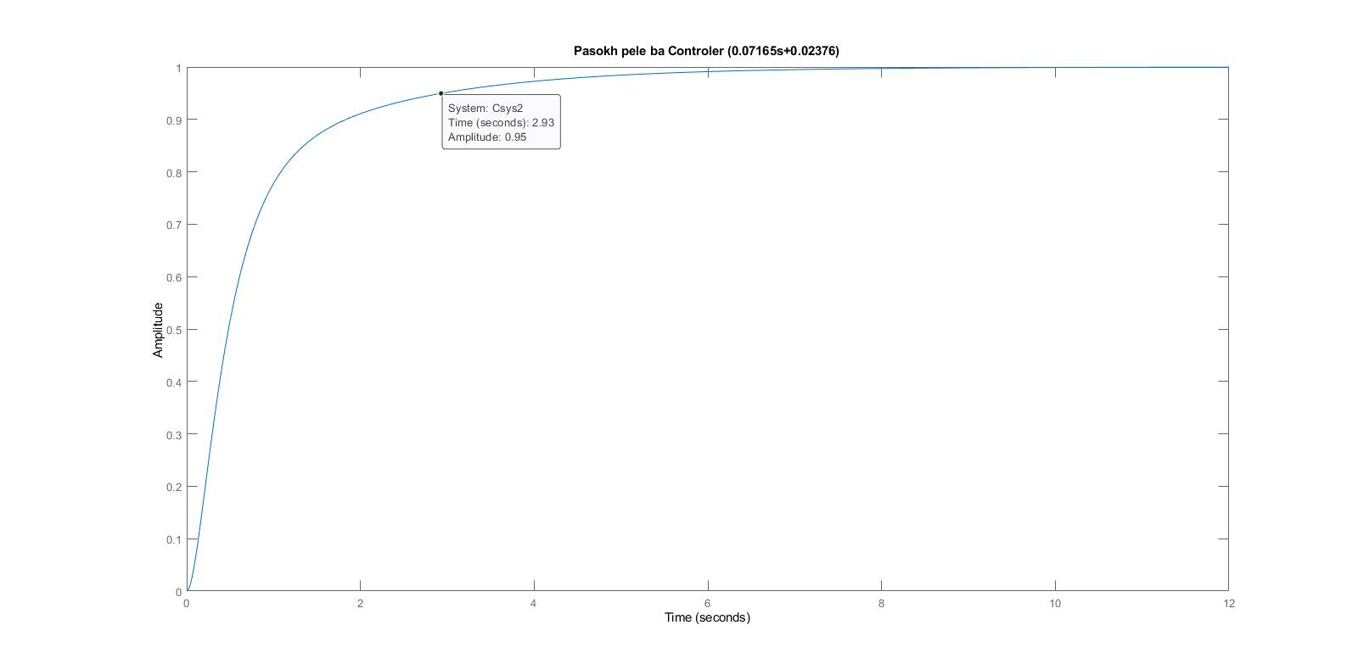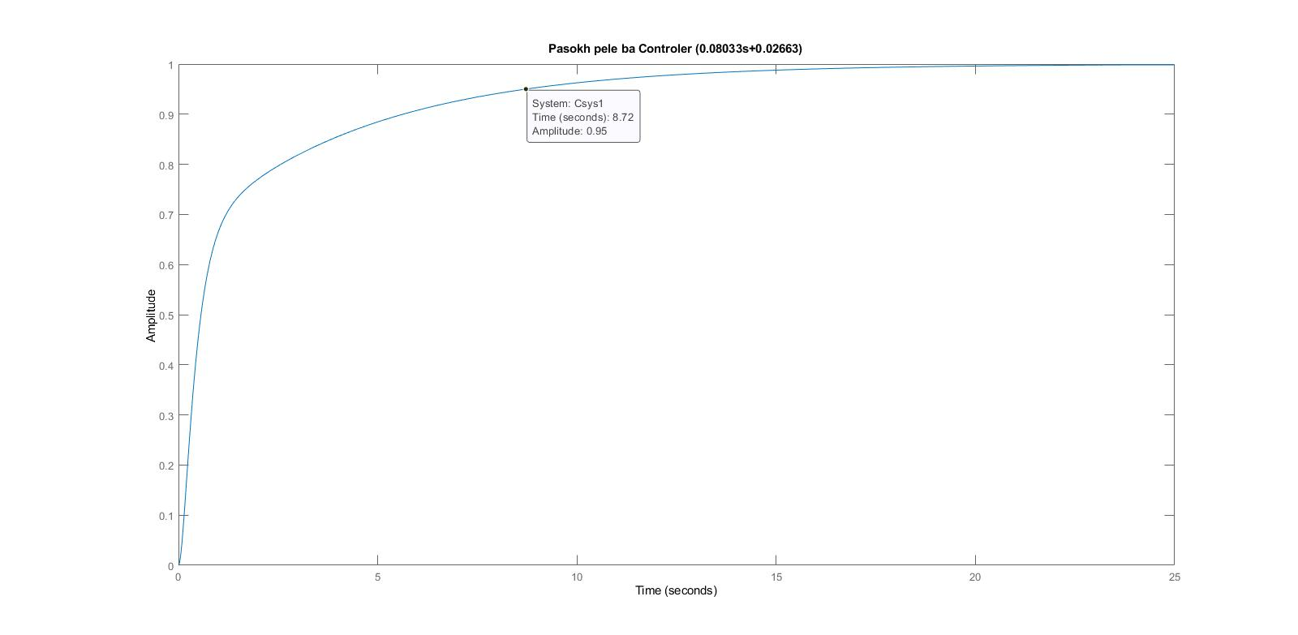الف) پاسخ پله :

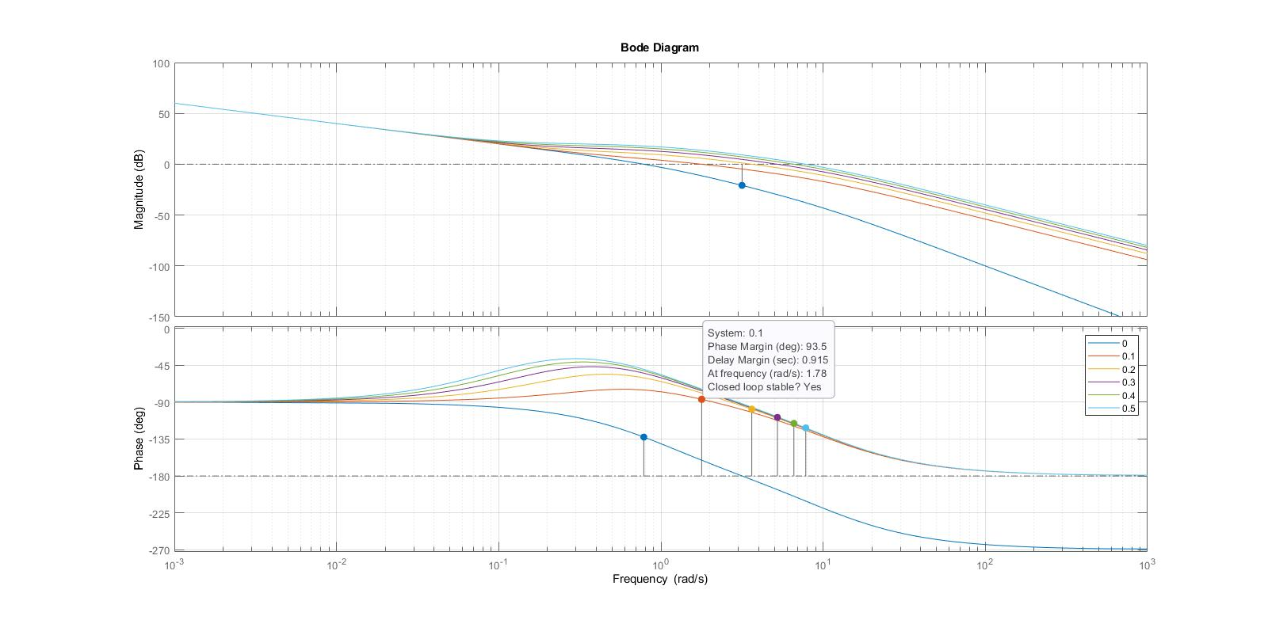ب)

کد متلب سوال 5 :

الف)

clc;

clear all;

close all;

s=tf('s');

Cs1=0.08033\*s+0.02663;

Cs2=0.085922\*s+0.0601;

num=Cs1\*200;

num1=Cs2\*200;

%num1 =5\*(s+1);

den=s\*(s+1)\*(s+10);

sys=num/den;

sys1=num1/den;

%sys1=num1/den;

disp('Open loop with Controller (0.08033s + 0.02663): ');

sys

disp('Open loop with Controller (0.07165s + 0.02376): ');

sys1

%display(sys1);

Csys1=sys/(1+sys);

Csys2=sys1/(1+sys1);

disp('Closed loop with Controller (0.08033s + 0.02663): ');

Csys1

disp('Closed loop with Controller (0.07165s + 0.02376): ');

Csys2

figure

step(Csys1);

title('Pasokh pele ba Controler (0.08033s+0.02663)');

figure

step(Csys2)

title('Pasokh pele ba Controler (0.07165s+0.02376)');

ب)

clc;

clear all;

close all;

% define Controller

s=tf('s');

Cs1=0.05;

Cs2=0.05+0.1\*s;

Cs3=0.05+0.2\*s;

Cs4=0.05+0.3\*s;

Cs5=0.05+0.4\*s;

Cs6=0.05+0.5\*s;

% define SYS

num1=Cs1\*200;

num2=Cs2\*200;

num3=Cs3\*200;

num4=Cs4\*200;

num5=Cs5\*200;

num6=Cs6\*200;

%num1 =5\*(s+1);

den=s\*(s+1)\*(s+10);

sys1=num1/den;

sys2=num2/den;

sys3=num3/den;

sys4=num4/den;

sys5=num5/den;

sys6=num6/den;

%sys1=num1/den;

figure

hold on

bode(sys1);

bode(sys2);

bode(sys3);

bode(sys4);

bode(sys5);

bode(sys6);

legend('0','0.1','0.2','0.3','0.4','0.5');

grid on